Technologies:
Php
Doker
Sql
Simple WAF rules with Nginx or open-source tool.
Github: https://github.com/YousefSher/Simple_WAF
Schema
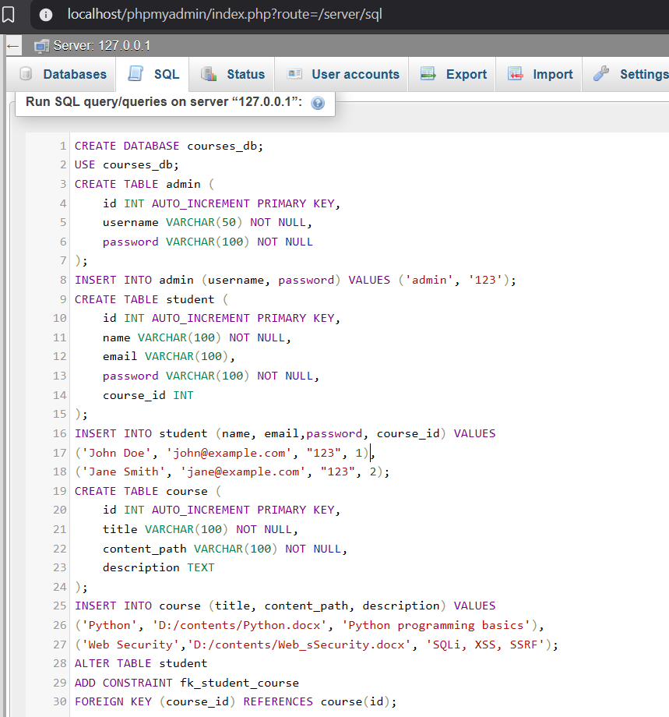
CREATE DATABASE courses_db;
USE courses_db;
CREATE TABLE admin (
id INT AUTO_INCREMENT PRIMARY KEY,
username VARCHAR(50) NOT NULL,
password VARCHAR(100) NOT NULL
);
INSERT INTO admin (username, password) VALUES ('admin', '123');
CREATE TABLE student (
id INT AUTO_INCREMENT PRIMARY KEY,
name VARCHAR(100) NOT NULL,
email VARCHAR(100),
password VARCHAR(100) NOT NULL,
course_id INT
);
INSERT INTO student (name, email,password, course_id) VALUES
('John Doe', 'john@example.com', "123", 1),
('Jane Smith', 'jane@example.com', "123", 2);
CREATE TABLE course (
id INT AUTO_INCREMENT PRIMARY KEY,
title VARCHAR(100) NOT NULL,
content_path VARCHAR(100) NOT NULL,
description TEXT
);
INSERT INTO course (title, content_path, description) VALUES
('Python', 'D:/contents/Python.docx', 'Python programming basics'),
('Web Security','D:/contents/Web_sSecurity.docx', 'SQLi, XSS, SSRF');
ALTER TABLE student
ADD CONSTRAINT fk_student_course
FOREIGN KEY (course_id) REFERENCES course(id);
Vulnerabilites:
Vulnerability | Scenario | Used?
Server-Side Request Forgery (SSRF) | - Vulnerability: OWASP A10: Server-Side Request Forgery  - The Logic: Takes a URL and the server fetches that image to save as a thumbnail.  - Normal URL: http://localhost/courses/index.php?page=import&url=http://google.com/logo.png  - Attack URL (The Hack): http://localhost/courses/index.php?page=import&url=http://localhost/phpmyadmin/ (This forces the server to scan its own internal network). | Yes
Cross-site scripting (xss) | - Vulnerability: OWASP A03: Injection (Cross-Site Scripting)  - The Logic: Takes a search term and echoes it back to the screen immediately.  - Normal URL: http://localhost/courses/index.php?page=search&q=python  - Attack URL (The Hack): http://localhost/courses/index.php?page=search&q=<script>alert('Hacked')</script> (This executes JavaScript in the browser). | Yes
SQL injection | - Vulnerability: OWASP A03: Injection (SQL)  - The Logic: Takes a username and queries the database without sanitization.  - Normal URL: http://localhost/courses/index.php?page=login&username=john_doe  - Attack URL (The Hack): http://localhost/courses/index.php?page=login&username=' OR 1=1 -- (This dumps the database users). | Yes
Security misconfiguration | - Vulnerability: OWASP A05: Security Misconfiguration  - The Logic: This isn't a PHP page; it is a static file that shouldn't be there. You need to manually create a dummy file named config.php.bak in your folder to test this.  - Normal URL: None (Users shouldn't know this exists).  - Attack URL (The Hack): http://localhost/courses/config.php.bak (This downloads the sensitive backup file). | Yes
Directory traversal | - Vulnerability: OWASP A01: Broken Access Control  - The Logic: Takes a filename and tries to open it from the materials/ folder.  - Normal URL: http://localhost/courses/index.php?page=download&file=intro.pdf  - Attack URL (The Hack): http://localhost/courses/index.php?page=download&file=../../../../windows/win.ini (This attempts to climb out of the folder to read system files). | Yes
DDoS attacks
Broken authentication
Sensitive data exposure
Broken access control
Protocol attack
Web application firewalls
Cross-site request forgery (csrf)
Injection

Directory traversal, Security misconfiguration, SQL injection, Cross-site scripting (xss), Server-Side Request Forgery (SSRF).
Gemini: https://gemini.google.com/share/f96770a7a2c5
courses
├───index.php
│
├───pages
│ ├───import.php
│ ├───search.php
│ ├───login.php
│ └───download.php
│
│ ├───models
│ │ ├───Student.php
│ │ ├───Course.php
│ │ └───Admin.php │
└───README.md
What is WAF?
combines the functions of a reverse proxy, sitting in front of web servers to manage traffic, with WAF security, acting as a shield to inspect, filter, and block malicious requests (like SQL injection, XSS) before they reach applications
How It Works
Interception: All incoming client requests first hit the reverse proxy.
Inspection: The integrated WAF analyzes this traffic for known attack patterns, malicious payloads, and policy violations.
Filtering: Harmful requests are blocked (returning a 403 Forbidden, for example), while legitimate ones are forwarded.
Forwarding: The proxy sends allowed requests to the appropriate backend server, often hiding the server's IP and distributing load.
Key Benefits
Data Security: Protects against common web attacks (SQLi, XSS, etc.).
Hides Servers: Obscures origin server IPs and architecture.
Load Balancing: Distributes traffic to prevent server overload.
SSL/TLS Offloading: Handles encryption/decryption, reducing server CPU load.
Caching: Caches static content, improving speed.
Common Implementations
NGINX: Often used as a base, with modules like ModSecurity for WAF functionality.
Cloud Solutions: Cloudflare, Zscaler, and others provide WAF/reverse proxy services.
Appliance/Software: Solutions from F5, Kemp Technologies offer integrated reverse proxy and WAF features.
Forward vs Reverse proxy
Feature | Forward Proxy | Reverse Proxy
Serves | Client | Server
Hides | Client IP | Server IP/Architecture
Control | Client-side configuration | Server-side management
Benefit | User privacy, access | Server performance, security

Notes:
First 4 vulnerabilities of wasp
Demo: See attacks before WAF and after WAF

How Does WAF Prevent XSS Attacks
#cybersecurity#infosec
Cross-Site Scripting (XSS) attacks are a type of security vulnerability found in web applications that allow attackers to inject malicious scripts into web pages viewed by other users. These scripts can then be executed in the context of the victim's browser, potentially leading to unauthorized actions, data theft, session hijacking, and more.

How XSS Attacks Work
1. Injection: An attacker identifies a vulnerable web application that does not properly sanitize user inputs.
2. Script Injection: The attacker injects a malicious script (usually JavaScript) into the input fields or URL parameters.
3. Execution: When other users visit the affected web page, the malicious script is executed by their browser.
4. Impact: The script can perform various malicious actions, such as stealing cookies, logging keystrokes, redirecting users to malicious sites, or displaying fake login forms.

Types of XSS Attacks
1. Stored (Persistent) XSS:
- Description: The malicious script is permanently stored on the target server, such as in a database, message forum, comment field, or user profile.
- Execution: When a victim visits the web page that retrieves and displays the stored data, the malicious script is executed in their browser.
- Impact: Can affect multiple users and persist over time, making it particularly dangerous.
2. Reflected (Non-Persistent) XSS:
- Description: The malicious script is reflected off a web server, typically via a URL parameter or form submission.
- Execution: The attacker tricks the victim into clicking a malicious link or submitting a form, causing the server to include the script in its response.
- Impact: Typically affects only a single user at a time and requires user interaction, such as clicking a link.
3. DOM-based XSS:
- Description: The vulnerability exists in the client-side code rather than server-side code. The malicious script is injected and executed by modifying the Document Object Model (DOM) in the victim's browser.
- Execution: The script is executed as part of the browser’s processing of the page, often without any interaction with the server.
- Impact: Can be more difficult to detect and mitigate since it doesn’t rely on server-side code.

Examples of XSS Attacks
- Stored XSS Example: An attacker posts a comment on a blog containing the following script:
<script>alert('XSS');</script>
Any user viewing the comments section will see the alert, indicating the script was executed.
- Reflected XSS Example: An attacker crafts a URL with a malicious script:
http://example.com/search?q=<script>alert('XSS');</script>
If the server includes the q parameter in its response without proper sanitization, the script will execute in the victim’s browser.

Prevention of XSS Attacks
1. Input Validation and Sanitization:
- Escape User Input: Properly escape special characters in user inputs to prevent them from being interpreted as code.
- Whitelist Input: Use a whitelist approach to validate and allow only expected input values.
2. Output Encoding:
- HTML Encoding: Encode characters before displaying user input in HTML to prevent the browser from interpreting them as code.
- JavaScript Encoding: Use proper encoding when inserting user input into JavaScript code.
3. Content Security Policy (CSP):
- Policy Implementation: Implement a CSP to restrict the sources from which scripts can be loaded and executed. This helps mitigate the impact of XSS by blocking unauthorized scripts.
4. HTTPOnly Cookies:
- Cookie Security: Set the HttpOnly flag on cookies to prevent client-side scripts from accessing them, reducing the risk of session hijacking via XSS.
5. Frameworks and Libraries:
- Use Secure Frameworks: Utilize web development frameworks and libraries that provide built-in protection against XSS, such as auto-escaping output.
6. Regular Security Audits:
- Code Reviews: Perform regular security reviews and audits of your codebase to identify and fix XSS vulnerabilities.
7. Web Application Firewalls (WAF):
Use WAFs to filter out malicious traffic before it reaches the application.

How Does WAF Prevent XSS Attacks
A Web Application Firewall (WAF) prevents Cross-Site Scripting (XSS) attacks by employing a range of detection and mitigation techniques that inspect, filter, and block malicious requests before they reach the web application. Here’s how a WAF typically accomplishes this:
1. Input Validation and Sanitization
- Signature-Based Detection: WAFs maintain a database of known attack patterns and signatures specific to XSS. They analyze incoming traffic for these patterns, such as <script>, onerror=, and other common XSS vectors, and block requests that match.
- Sanitization Filters: The WAF can sanitize input data by removing or encoding potentially dangerous characters and scripts before passing it to the web application. This helps neutralize malicious content.
2. Behavioral Analysis
- Anomaly Detection: WAFs monitor traffic for unusual patterns that deviate from normal behavior. Requests that exhibit suspicious behavior, such as containing unexpected or malformed data, can be flagged and blocked.
- Machine Learning: Some advanced WAFs utilize machine learning algorithms to understand normal traffic patterns and identify anomalies that may indicate an XSS attack.
3. Contextual Awareness
- Contextual Inspection: The WAF understands the context of where the input is used (e.g., in a URL, form field, or cookie) and applies specific rules for different contexts. This contextual awareness helps in accurately identifying and blocking XSS payloads.
- Application Profiling: By profiling the typical behavior and structure of the web application, the WAF can detect and block requests that deviate from the norm.
4. Heuristic Techniques
- Heuristic Analysis: WAFs use heuristic techniques to detect XSS attacks based on the behavior and structure of the request. These rules can identify sophisticated or obfuscated XSS payloads that may not match known signatures.
5. Content Security Policy (CSP) Enforcement
- CSP Headers: While primarily a server-side security feature, some WAFs can help enforce Content Security Policies by ensuring that the correct CSP headers are set. CSP restricts the sources from which scripts can be loaded and executed, mitigating the risk of XSS.
6. Rate Limiting and Throttling
- Rate Limiting: By limiting the rate of incoming requests from a single IP address, WAFs can mitigate automated XSS attacks. This is especially useful against bots and scripts attempting to exploit vulnerabilities at scale.
- Throttling: The WAF can slow down requests to reduce the risk of successful rapid-fire XSS attacks.
7. Output Encoding and Filtering
- Response Filtering: Some WAFs can analyze and modify server responses to ensure that any potentially dangerous content is properly encoded or removed before reaching the user's browser. This helps prevent stored XSS attacks.
- Dynamic Content Scanning: WAFs can dynamically scan and sanitize content served to users, especially in user-generated content scenarios.
8. Logging and Alerts
- Detailed Logging: All detected and blocked XSS attempts are logged in detail, providing valuable information for forensic analysis and understanding attack vectors.
- Real-Time Alerts: The WAF can send real-time alerts to administrators when an XSS attempt is detected, allowing for immediate investigation and response.
9. Integration with Other Security Tools
- SIEM Integration: WAFs can integrate with Security Information and Event Management (SIEM) systems to provide a comprehensive view of security events and facilitate a coordinated response.
- Collaboration with IDS/IPS: By working alongside Intrusion Detection and Prevention Systems (IDS/IPS), the WAF enhances overall security posture and provides layered defense.
10. Regular Updates and Maintenance
- Signature Updates: WAFs receive regular updates to their signature databases to stay current with the latest XSS attack techniques and vectors.
- Rule Tuning: Continuous tuning and updating of rules ensure that the WAF remains effective against evolving threats.
SafeLine WAF combines these techniques and effectively prevents XSS attacks, ensuring that malicious scripts are blocked before they can exploit vulnerabilities in the web application and harm users.

